Data Analysis

The below-listed image shows some of the data values available in the Exam’s data.

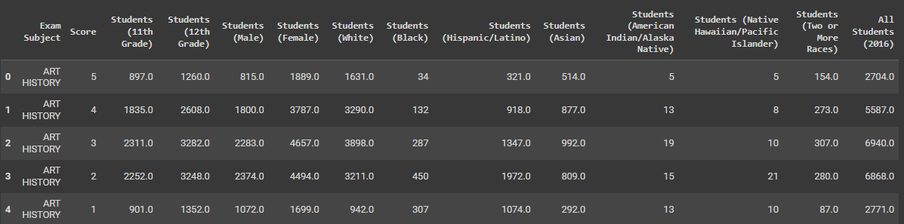

Data information about the Student’s data

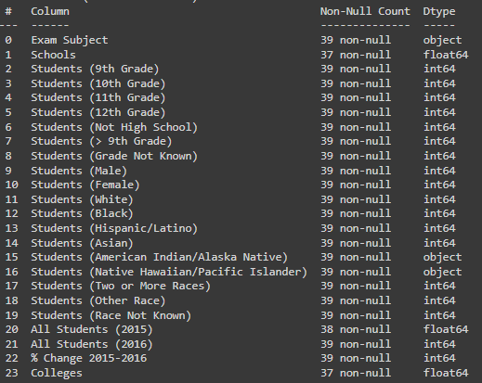

The image below shows how the percentage of student enrollment has changed over time. This shows the student’s placement offers great well-being in the future scope of the students. The increased number of placements impacts the student’s interactions with the colleges' tie-ups.

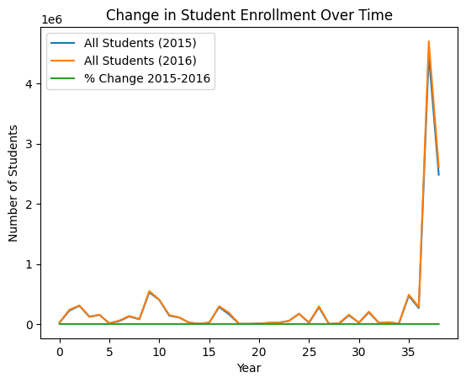

The Chi-Square Test being performed shows the statistical technique which are used to analyse and determine if two nominal scale variables are independent. In this context, it helps in predicting whether the distribution of male students in the examinations is random or has a specific pattern.

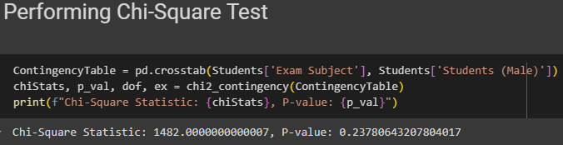

The p-value, obtained from this test helps in analysing the likelihood of getting such a value of the statistic whenever the two are not related. A p-value less than 0.05 per cent point is regarded as statistically significant. Thus, the analysis being performed shows a p-value of 0.05 where the hypothesis of independence is rejected implying that there might be a gender preference in the type of examination.

Moving further, the One-Way Analysis of Variance (ANOVA) is used for analysing differences of a continuous variable between two or more independent groups. Here, its goal is to determine whether students’ average exam scores depend on the racial group of the students.

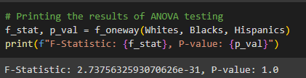

F-statistic is the ratio between inter-group variance and within-group variance where it can be observed that the F-statistics of 2.73 is defined as the statistic accompanied by a low p-value of 1. This means that not all the groups have equal mean, there is a hint of racial difference in the exam results.

In addition to the Linear regression analysis, the modelling forecasts the value of a dependent variable of one or more independent variables. This way, the analysis being performed has established the following model in a bid to predict student total count using demography-related variables.

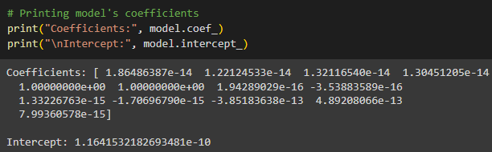

The values of Coefficients and Intercepts indicate that the regression coefficient represents how much the dependent variable can be expected to change, given a one-unit change in the predictor variable while all other variables are held constant. On the other hand, Intercept refers to the value of the dependent variable in the model if all the predictor variables have their median values.

In this way, these statistics methodologies provide insight into the emergence and fluctuation of demographic factors concerning the choice of curricula and academic performance. They emphasized the fact that all these variables should be taken into consideration when making plans and policies within the sphere of education to provide equal opportunities for studying.

In conclusion, the statistical tests have been integrated with the research question being proposed which can be considered the results' significance and implications. For Example, if the tests indicate disparities in participation or performance among different groups, this could inform discussions on educational equity in AP Computer Science Principles, leading to targeted interventions or policy recommendations.